Hands-on Assignment(Interacting with Oracle Database Server)
Write a program that displays the Netsal (Sal + Comm) of an employee entered at run time from EMP table. (Use NVL Function.)
Program:
SET SERVEROUTPUT ON;
DECLARE
V_EMPNO EMP.EMPNO%TYPE;
V_NETSAL NUMBER;
BEGIN
V_EMPNO := &EMPNO;
SELECT SAL + NVL(COMM, 0)
INTO V_NETSAL
FROM EMP
WHERE EMPNO = V_EMPNO;
DBMS_OUTPUT.PUT_LINE('Employee Number : ' || V_EMPNO);
DBMS_OUTPUT.PUT_LINE('Net Salary : ' || V_NETSAL);
EXCEPTION
WHEN NO_DATA_FOUND THEN
DBMS_OUTPUT.PUT_LINE('Employee Not Found');
END;
/
Output:
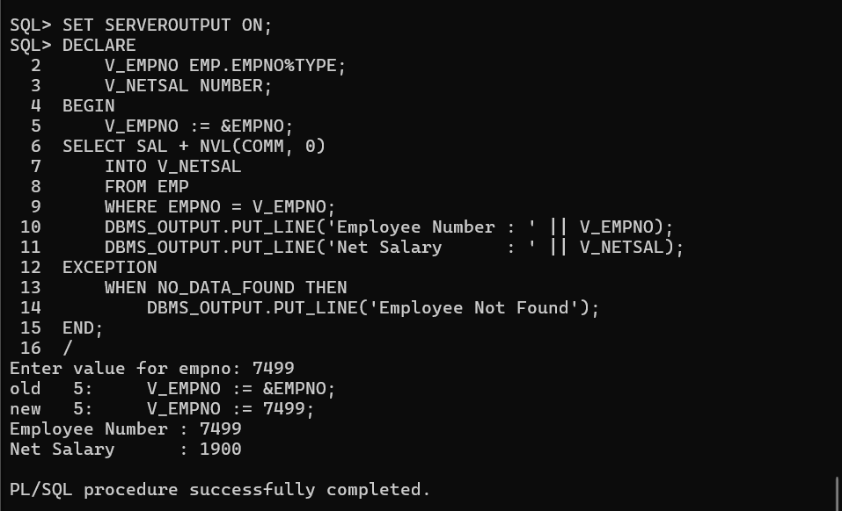

Hands-on Assignment(Writing Control Structures)
1.Write a program that will prompt for a EMPNO, ENAME, SAL. If EMPNO does not exist in EMP table then INSERT the EMPNO, ENAME, SAL into the EMP table else UPDATE ENAME, SAL for that EMPNO.
Program:
SET SERVEROUTPUT ON
DECLARE
V_EMPNO EMP.EMPNO%TYPE;
V_ENAME EMP.ENAME%TYPE;
V_SAL EMP.SAL%TYPE;
V_COUNT NUMBER;
BEGIN
V_EMPNO := &EMPNO;
V_ENAME := '&ENAME';
V_SAL := &SAL;
SELECT COUNT(*)
INTO V_COUNT
FROM EMP
WHERE EMPNO = V_EMPNO;
IF V_COUNT = 0 THEN
INSERT INTO EMP(EMPNO, ENAME, SAL)
VALUES(V_EMPNO, V_ENAME, V_SAL);
DBMS_OUTPUT.PUT_LINE('Record Inserted Successfully');
ELSE
UPDATE EMP
SET ENAME = V_ENAME,
SAL = V_SAL
WHERE EMPNO = V_EMPNO;
DBMS_OUTPUT.PUT_LINE('Record Updated Successfully');
END IF;
COMMIT;
END;
/

Output:
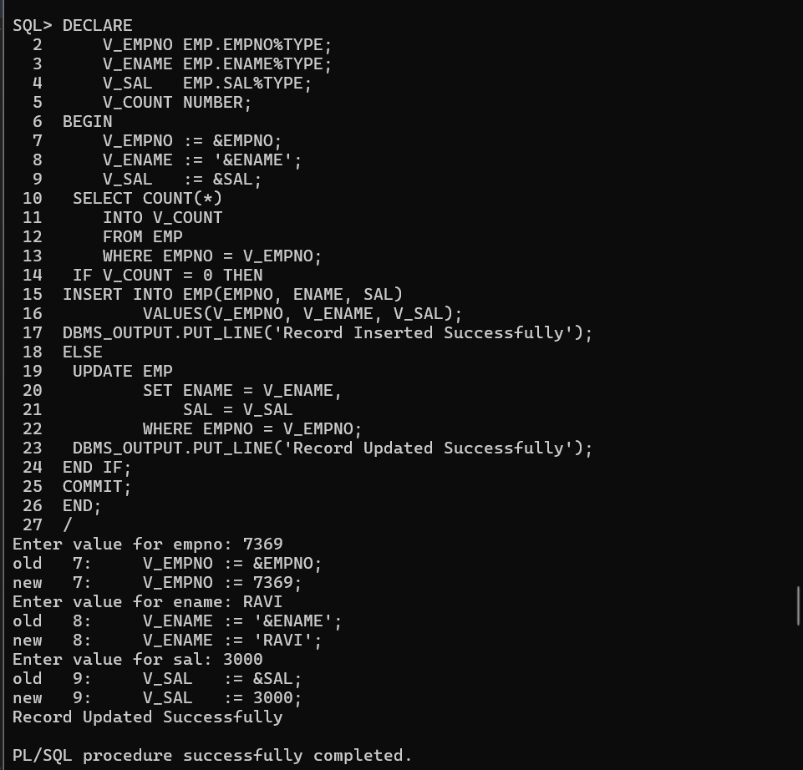

2. Write a program that will prompt for number and display whether the number is ODD or EVEN number.
Program:
SET SERVEROUTPUT ON;
DECLARE
V_NUM NUMBER;
BEGIN
V_NUM := &NUMBER;
IF MOD(V_NUM, 2) = 0 THEN
DBMS_OUTPUT.PUT_LINE(V_NUM || ' is EVEN number');
ELSE
DBMS_OUTPUT.PUT_LINE(V_NUM || ' is ODD number');
END IF;
END;
/
Output:
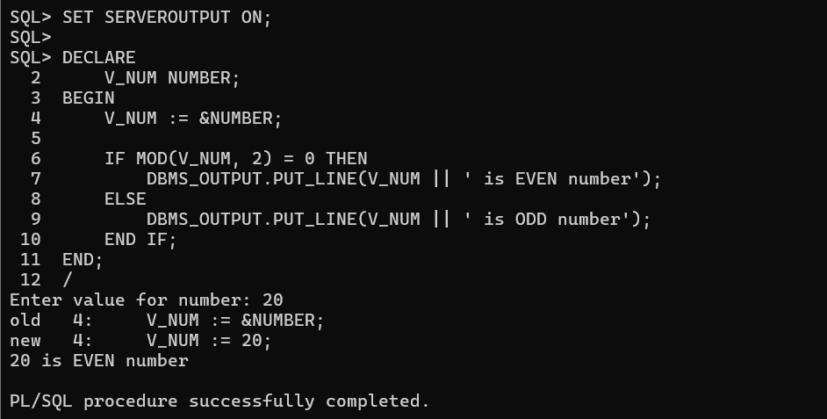

3.write program that prompts for EMPNO and update his salary based on the below specification:
If the employee belongs to DEPTNO 10 then update his salary by 10%.
If the employee belongs to DEPTNO 20 then update his salary by 15%.
If the employee belongs to other DEPTNO then update his salary with SALARY+COMM.
Program:
SET SERVEROUTPUT ON;
DECLARE
V_EMPNO EMP.EMPNO%TYPE;
V_SAL EMP.SAL%TYPE;
V_COMM EMP.COMM%TYPE;
V_DEPTNO EMP.DEPTNO%TYPE;
BEGIN
V_EMPNO := &EMPNO;
SELECT SAL, COMM, DEPTNO
INTO V_SAL, V_COMM, V_DEPTNO
FROM EMP
WHERE EMPNO = V_EMPNO;
IF V_DEPTNO = 10 THEN
UPDATE EMP
SET SAL = SAL + (SAL * 10 / 100)
WHERE EMPNO = V_EMPNO;
DBMS_OUTPUT.PUT_LINE('Salary updated by 10%');
ELSIF V_DEPTNO = 20 THEN
UPDATE EMP
SET SAL = SAL + (SAL * 15 / 100)
WHERE EMPNO = V_EMPNO;
DBMS_OUTPUT.PUT_LINE('Salary updated by 15%');
ELSE
UPDATE EMP
SET SAL = SAL + NVL(COMM, 0)
WHERE EMPNO = V_EMPNO;
DBMS_OUTPUT.PUT_LINE('Salary updated with SALARY + COMM');
END IF;
COMMIT;
END;
/
Output:
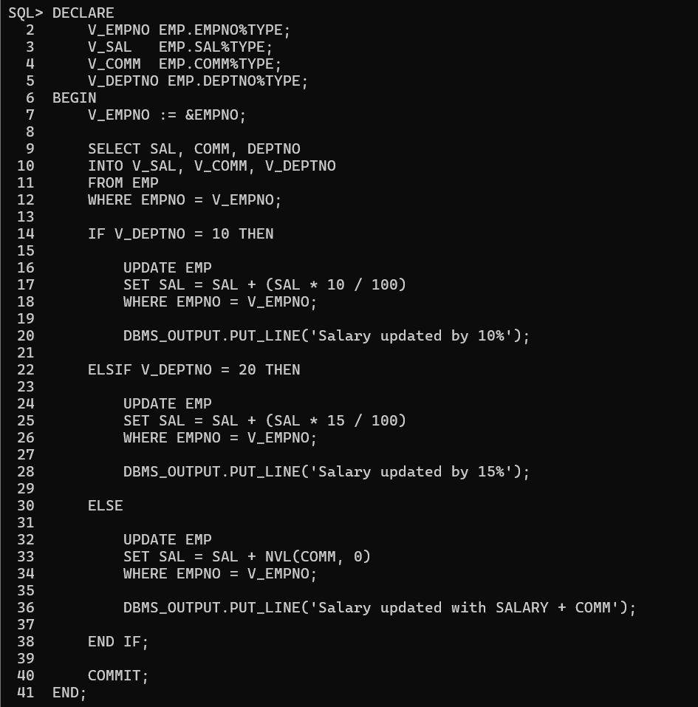
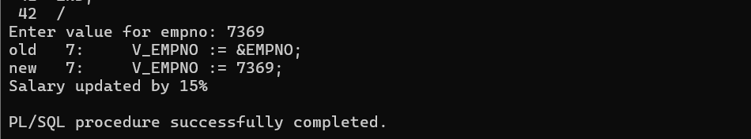

4.In sql Prompt creates a table MYTABLE1 with RESULT as a column of number datatype.
Write a program that will insert record in the mytable from 1,2,3… to 10 values.
Do not insert record 6 and 8
Program:
CREATE TABLE MYTABLE1 (RESULT NUMBER);
SET SERVEROUTPUT ON;
BEGIN
FOR I IN 1..10
LOOP
IF I <> 6 AND I <> 8 THEN
INSERT INTO MYTABLE1(RESULT)
VALUES(I);
END IF;
END LOOP;
COMMIT;
DBMS_OUTPUT.PUT_LINE('Records Inserted Successfully');
END;
/
SELECT * FROM MYTABLE1;
Output:
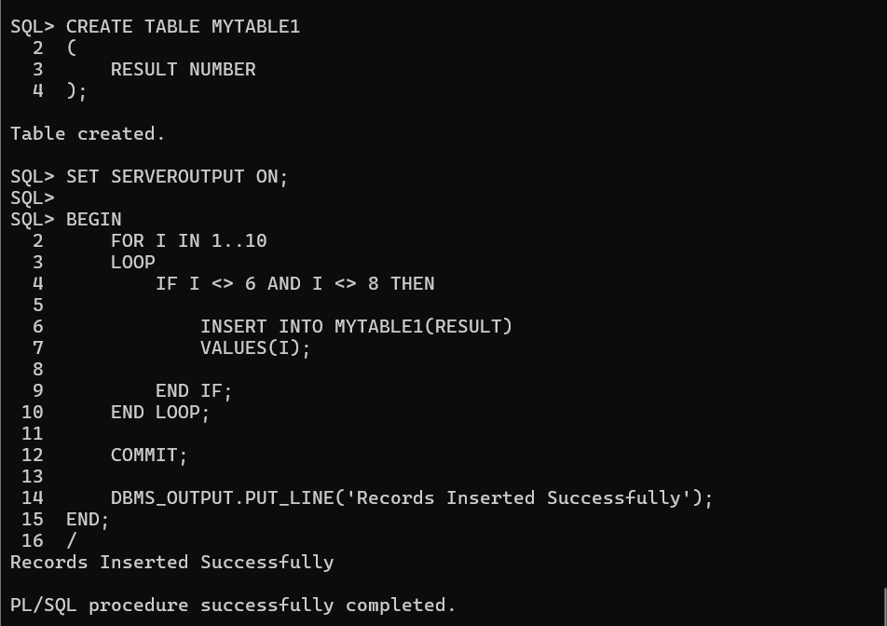

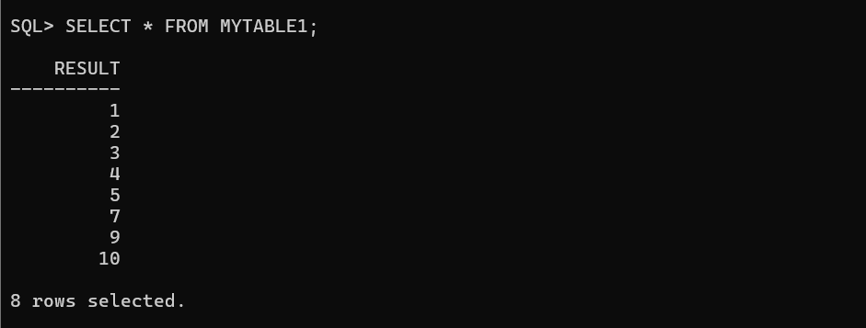

Hands-on Assignment(Working With Composite Data Types)
Write a program that will display the entire row by passing the EMPNO. (Use %ROWTYPE)
Program:
SET SERVEROUTPUT ON;
DECLARE
V_EMPNO EMP.EMPNO%TYPE;
V_EMP EMP%ROWTYPE;
BEGIN
V_EMPNO := &EMPNO;
SELECT *
INTO V_EMP
FROM EMP
WHERE EMPNO = V_EMPNO;
DBMS_OUTPUT.PUT_LINE('EMPNO : ' || V_EMP.EMPNO);
DBMS_OUTPUT.PUT_LINE('ENAME : ' || V_EMP.ENAME);
DBMS_OUTPUT.PUT_LINE('JOB : ' || V_EMP.JOB);
DBMS_OUTPUT.PUT_LINE('SAL : ' || V_EMP.SAL);
DBMS_OUTPUT.PUT_LINE('COMM : ' || V_EMP.COMM);
DBMS_OUTPUT.PUT_LINE('DEPTNO : ' || V_EMP.DEPTNO);
EXCEPTION
WHEN NO_DATA_FOUND THEN
DBMS_OUTPUT.PUT_LINE('Employee Not Found');
END;
/

Output:
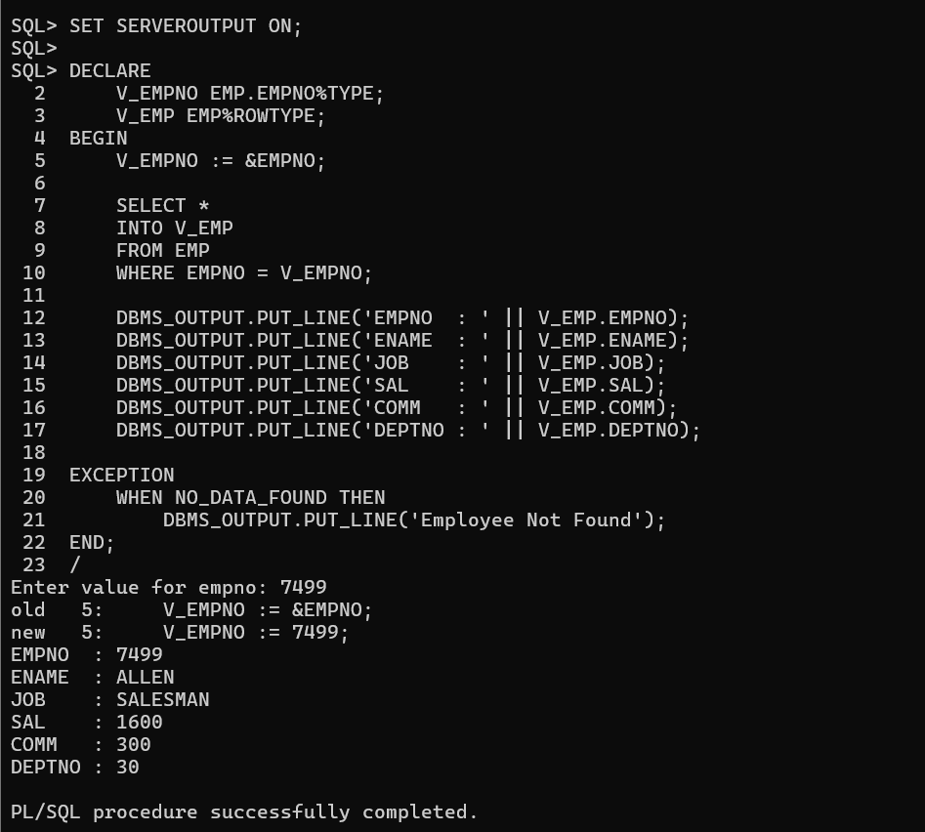

Hands-on Assignment(Explicit Cursor)
- Write a implicit cursor that will prompt for a JOB and delete the employees working in that Job. Store the number of records deleted in a session variable.
Program:
SET SERVEROUTPUT ON;
VARIABLE V_COUNT NUMBER;
DECLARE
V_JOB EMP.JOB%TYPE;
BEGIN
V_JOB := '&JOB';
DELETE FROM EMP
WHERE JOB = V_JOB;
:V_COUNT := SQL%ROWCOUNT;
DBMS_OUTPUT.PUT_LINE('Number of records deleted: ' || :V_COUNT);
COMMIT;
END;
/
Output:
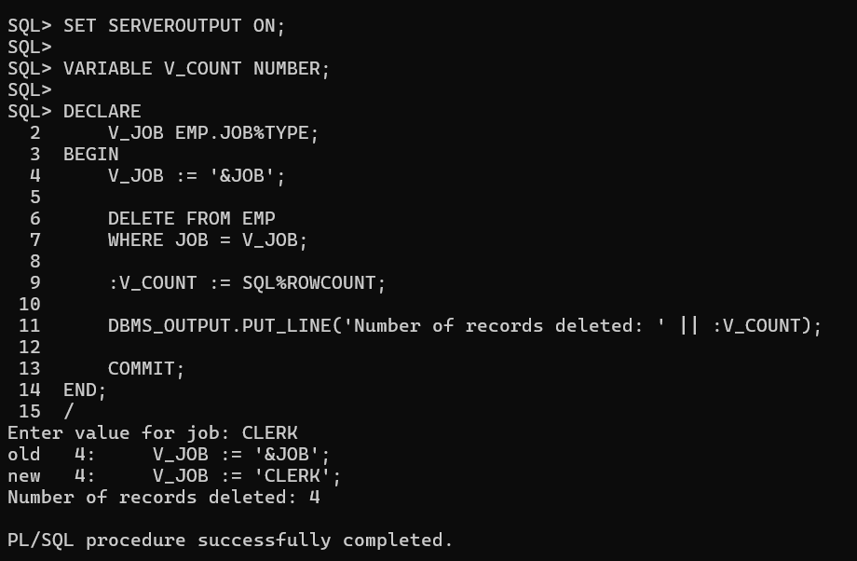

2.Rollback the previous Delete Statement.
Query:
ROLLBACK;
SELECT * FROM EMP;
Output: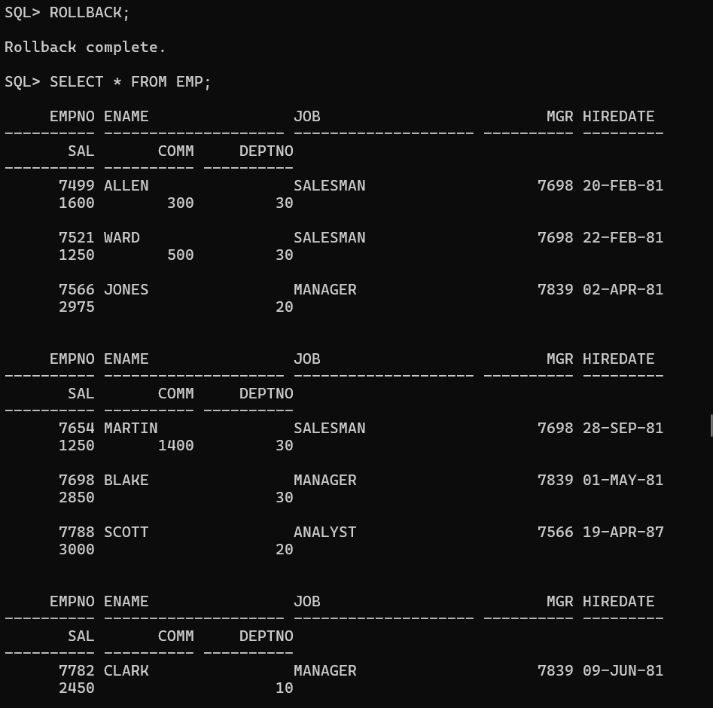
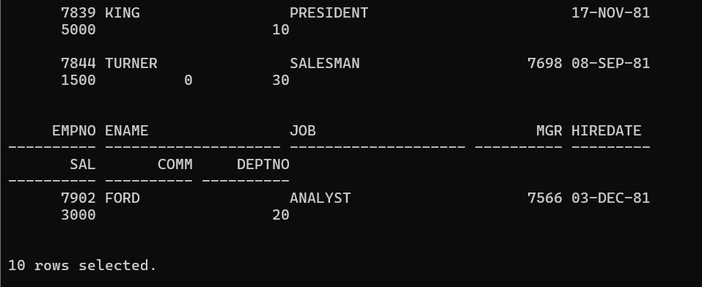

3.Write a program that displays the Top N salaries using simple Explicit Cursors.
Program:
SET SERVEROUTPUT ON;
DECLARE
CURSOR C_EMP(V_N NUMBER) IS
SELECT ENAME, SAL
FROM EMP
ORDER BY SAL DESC;
V_NAME EMP.ENAME%TYPE;
V_SAL EMP.SAL%TYPE;
V_N NUMBER;
V_COUNT NUMBER := 0;
BEGIN
V_N := &N;
OPEN C_EMP(V_N);
LOOP
FETCH C_EMP INTO V_NAME, V_SAL;
EXIT WHEN C_EMP%NOTFOUND OR V_COUNT = V_N;
V_COUNT := V_COUNT + 1;
DBMS_OUTPUT.PUT_LINE(V_COUNT || '. ' || V_NAME || ' - ' || V_SAL);
END LOOP;
CLOSE C_EMP;
END;
/

Output:
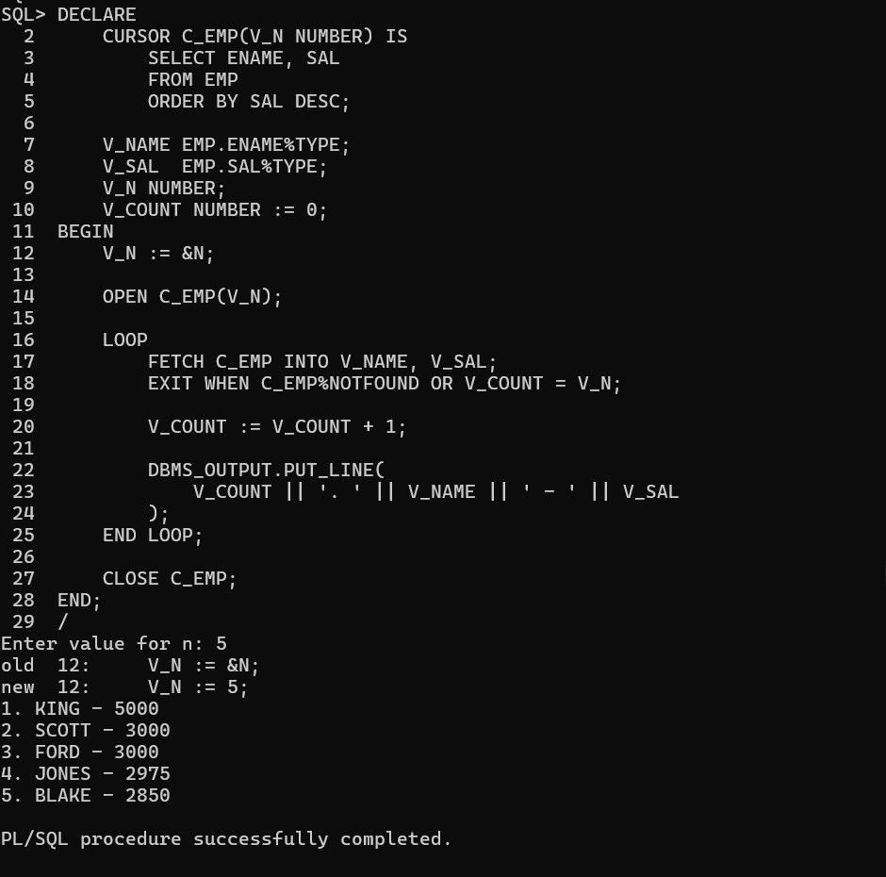

4.Create a Simple Explicit Cursor that displays all the employees who are earning more than the average salary of the EMP table.
Program:
SET SERVEROUTPUT ON;
DECLARE
V_AVG_SAL NUMBER;
CURSOR C_EMP IS
SELECT EMPNO, ENAME, SAL
FROM EMP
WHERE SAL > V_AVG_SAL;
BEGIN
SELECT AVG(SAL)
INTO V_AVG_SAL
FROM EMP;
DBMS_OUTPUT.PUT_LINE('Average Salary: ' || V_AVG_SAL);
DBMS_OUTPUT.PUT_LINE('Employees earning more than average:');
FOR R IN C_EMP
LOOP
DBMS_OUTPUT.PUT_LINE(R.EMPNO || ' ' || R.ENAME || ' ' || R.SAL);
END LOOP;
END;
/
Output:
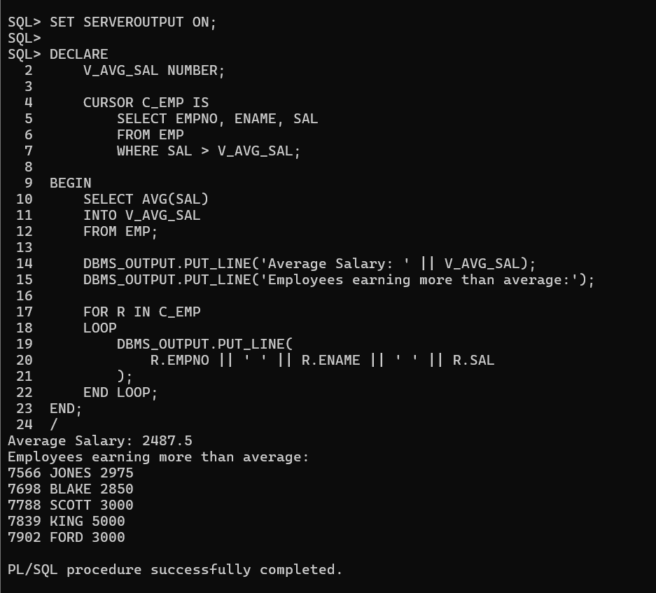
5. Create a Simple Explicit cursor that displays the employees who earn more than 2000 and have joined the company after 15-Jun-1981.
Print the output: < > earns < > and joined the organization on <>.
Program:
SET SERVEROUTPUT ON;
DECLARE
CURSOR C_EMP IS
SELECT ENAME, SAL, HIREDATE
FROM EMP
WHERE SAL > 2000
AND HIREDATE > TO_DATE('15-JUN-1981','DD-MON-YYYY');
BEGIN
FOR R IN C_EMP
LOOP
DBMS_OUTPUT.PUT_LINE(
R.ENAME || ' earns ' || R.SAL ||
' and joined the organization on ' || TO_CHAR(R.HIREDATE, 'DD-MON-YYYY'));
END LOOP;
END;
/
Output:
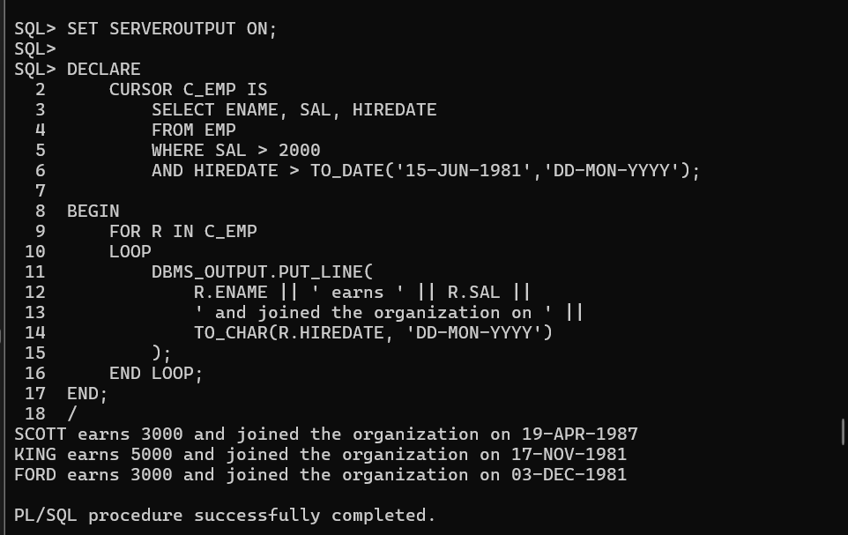

6. Create a Simple Explicit cursor that displays the hiredate in the format DD-MM-RRRR and Day. Sort the records on DAY starting from Saturday.
Program:
SET SERVEROUTPUT ON;
DECLARE
CURSOR C_EMP IS
SELECT ENAME,
HIREDATE,
TO_CHAR(HIREDATE, 'DD-MM-RRRR') AS HDATE,
TO_CHAR(HIREDATE, 'DAY') AS HDAY,
TO_CHAR(HIREDATE, 'D') AS DAY_NO
FROM EMP ORDER BY MOD(TO_NUMBER(TO_CHAR(HIREDATE, 'D')) + 1, 7);
BEGIN
FOR R IN C_EMP
LOOP
DBMS_OUTPUT.PUT_LINE( R.ENAME || ' - ' ||R.HDATE || ' - ' || TRIM(R.HDAY) );
END LOOP;
END;
/
Output:
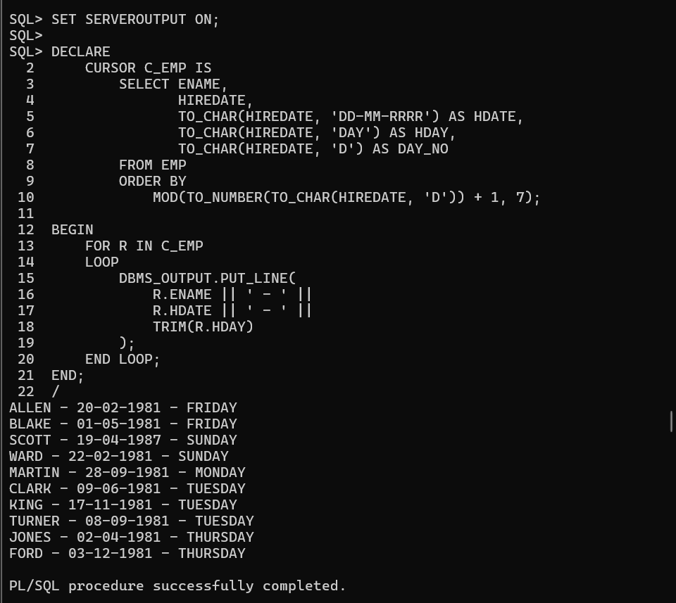

7. Create a simple explicit cursor that displays the employees names and commission amounts. If an employee does not earn commission, show "No Commission". Label the column COMM.
Program:
SET SERVEROUTPUT ON;
DECLARE
CURSOR C_EMP IS
SELECT ENAME,
NVL(TO_CHAR(COMM), 'No Commission') AS COMM FROM EMP;
BEGIN
DBMS_OUTPUT.PUT_LINE(RPAD('ENAME', 15) || 'COMM’ ); DBMS_OUTPUT.PUT_LINE('-----------------------------' );
FOR R IN C_EMP
LOOP
DBMS_OUTPUT.PUT_LINE(RPAD(R.ENAME, 15) || R.COMM );
END LOOP;
END;
/
Output:
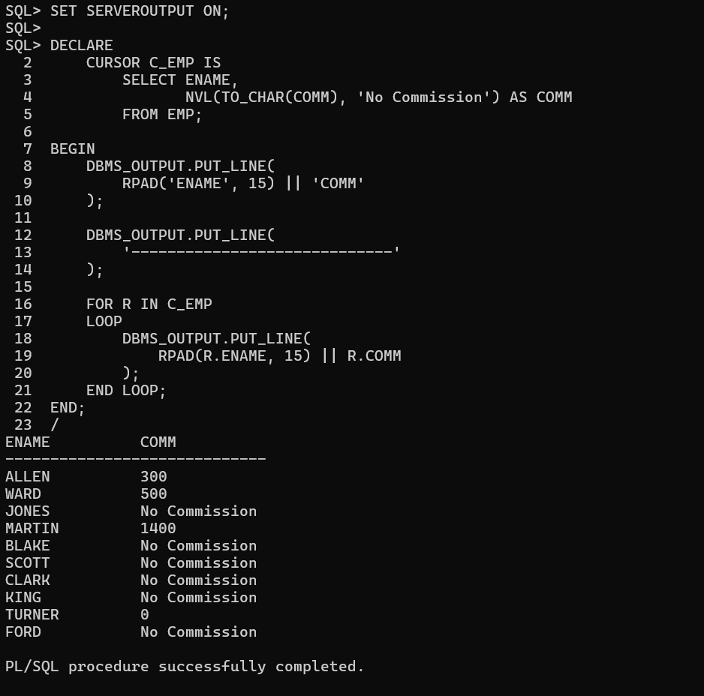
8. Create a parameter cursor that takes DEPTNO as a parameter and update the star column with *. Every * represents a 1000.
Example: If the employee salary is 5000 then update star column with *****.
Use Parameter Cursor, Cursor with FOR LOOP and WHERE CURRENT OF option.
Program:
SET SERVEROUTPUT ON;
DECLARE
CURSOR C_EMP(P_DEPTNO EMP.DEPTNO%TYPE) IS
SELECT SAL, STAR
FROM EMP
WHERE DEPTNO = P_DEPTNO
FOR UPDATE OF STAR;
V_DEPTNO NUMBER;
BEGIN
V_DEPTNO := &DEPTNO;
FOR R IN C_EMP(V_DEPTNO)
LOOP
UPDATE EMP
SET STAR = RPAD('*', TRUNC(R.SAL / 1000), '*')
WHERE CURRENT OF C_EMP;
END LOOP;
COMMIT;
DBMS_OUTPUT.PUT_LINE('STAR column updated successfully.');
END;
/
Output:
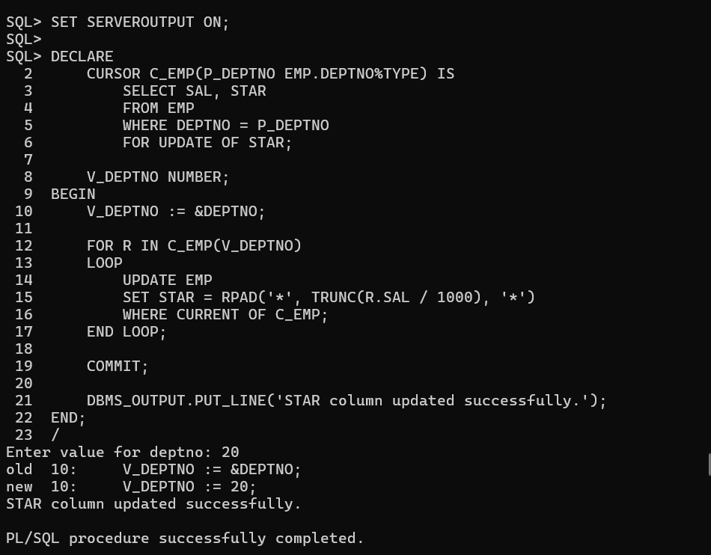

9. Write a Parameter Cursor program that promotes CLERK who earn more than 1000 to SR CLERK and increase the salary by 10%. Pass CLERK as a parameter to the Cursor. Use Parameter Cursor, Cursor with FOR LOOP and Cursor with UPDATE clause.
Program:
SET SERVEROUTPUT ON;
DECLARE
CURSOR C_EMP(P_JOB EMP.JOB%TYPE) IS
SELECT ENAME, SAL
FROM EMP
WHERE JOB = P_JOB
AND SAL > 1000
FOR UPDATE OF JOB, SAL;
BEGIN
FOR R IN C_EMP('CLERK')
LOOP
UPDATE EMP
SET JOB = 'SR CLERK',
SAL = SAL + (SAL * 10 / 100)
WHERE CURRENT OF C_EMP;
DBMS_OUTPUT.PUT_LINE(R.ENAME || ' promoted to SR CLERK' );
END LOOP;
COMMIT;
END;
/
Output:
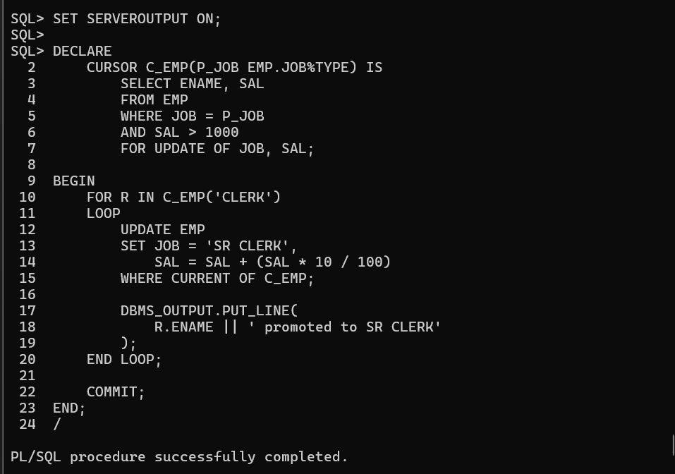

10. Display entire record from the DEPT table by passing a DEPTNO. Increase the Salary of employees working in deptno 10 by 15%, deptno 20 by 15% and others by 5%. Also display the corresponding employees working in that Dept.
Use a parameter Cursor, For Loop Cursor and Cursor with Update clause.
Program:
SET SERVEROUTPUT ON;
DECLARE
V_DEPTNO DEPT.DEPTNO%TYPE;
V_DNAME DEPT.DNAME%TYPE;
V_LOC DEPT.LOC%TYPE;
CURSOR C_EMP(P_DEPTNO EMP.DEPTNO%TYPE) IS
SELECT EMPNO, ENAME, SAL
FROM EMP
WHERE DEPTNO = P_DEPTNO
FOR UPDATE OF SAL;
BEGIN
V_DEPTNO := &DEPTNO;
SELECT DNAME, LOC
INTO V_DNAME, V_LOC
FROM DEPT
WHERE DEPTNO = V_DEPTNO;
DBMS_OUTPUT.PUT_LINE('DEPTNO : ' || V_DEPTNO);
DBMS_OUTPUT.PUT_LINE('DNAME : ' || V_DNAME);
DBMS_OUTPUT.PUT_LINE('LOC : ' || V_LOC);
DBMS_OUTPUT.PUT_LINE('Employees:');
FOR R IN C_EMP(V_DEPTNO)
LOOP
DBMS_OUTPUT.PUT_LINE(R.EMPNO || ' ' || R.ENAME ||' Salary: ' || R.SAL );
IF V_DEPTNO = 10 THEN
UPDATE EMP
SET SAL = SAL + (SAL * 15 / 100)
WHERE CURRENT OF C_EMP;
ELSIF V_DEPTNO = 20 THEN
UPDATE EMP
SET SAL = SAL + (SAL * 15 / 100)
WHERE CURRENT OF C_EMP;
ELSE
UPDATE EMP
SET SAL = SAL + (SAL * 5 / 100)
WHERE CURRENT OF C_EMP;
END IF;
END LOOP;
COMMIT;
END;
/
Output:
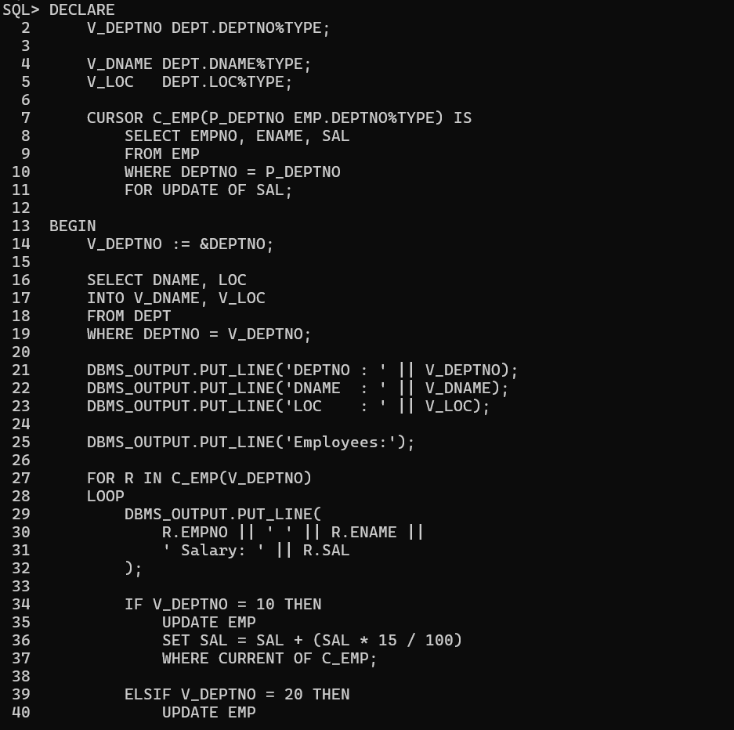
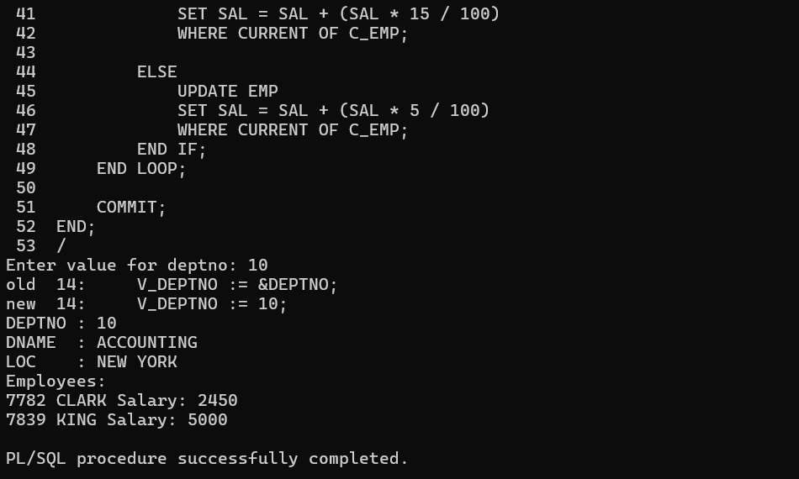

11. Write a program that will prompt the user for a CHOICE. If CHOICE is 1 then display all the employees who earn more than 2000 from EMP table else display all the Employees who earn less than 2000.Use REF CURSORS.
Program:
SET SERVEROUTPUT ON;
DECLARE
TYPE REF_CURSOR_TYPE IS REF CURSOR;
C_EMP REF_CURSOR_TYPE;
V_CHOICE NUMBER;
V_EMPNO EMP.EMPNO%TYPE;
V_ENAME EMP.ENAME%TYPE;
V_SAL EMP.SAL%TYPE;
BEGIN
V_CHOICE := &CHOICE;
IF V_CHOICE = 1 THEN
OPEN C_EMP FOR
SELECT EMPNO, ENAME, SAL
FROM EMP WHERE SAL > 2000;
DBMS_OUTPUT.PUT_LINE('Employees earning more than 2000:’ );
ELSE
OPEN C_EMP FOR
SELECT EMPNO, ENAME, SAL
FROM EMP
WHERE SAL < 2000;
DBMS_OUTPUT.PUT_LINE('Employees earning less than 2000:’);
END IF;
LOOP
FETCH C_EMP INTO V_EMPNO, V_ENAME, V_SAL;
EXIT WHEN C_EMP%NOTFOUND;
DBMS_OUTPUT.PUT_LINE( V_EMPNO || ' ' || V_ENAME || ' ' || V_SAL );
END LOOP;
CLOSE C_EMP;
END;
/
Output:
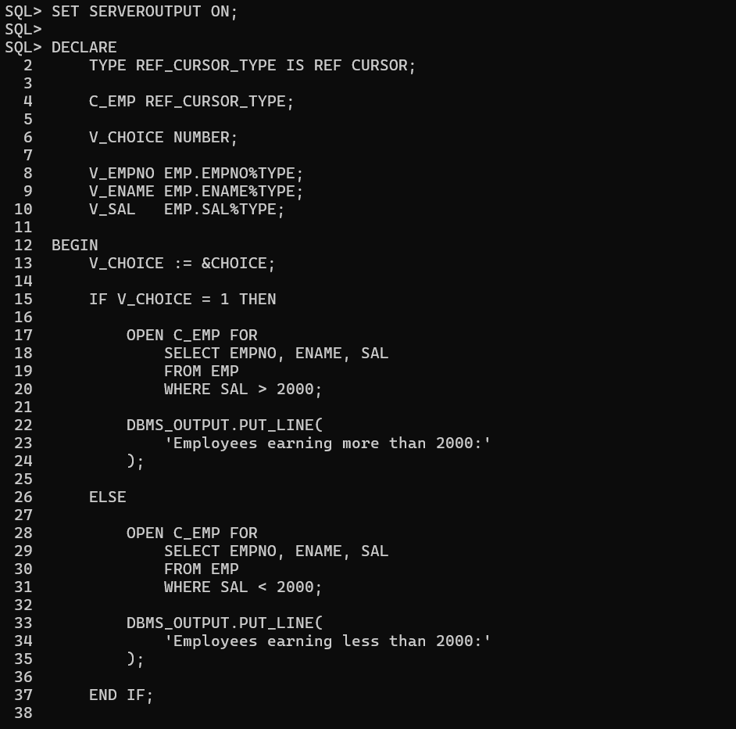
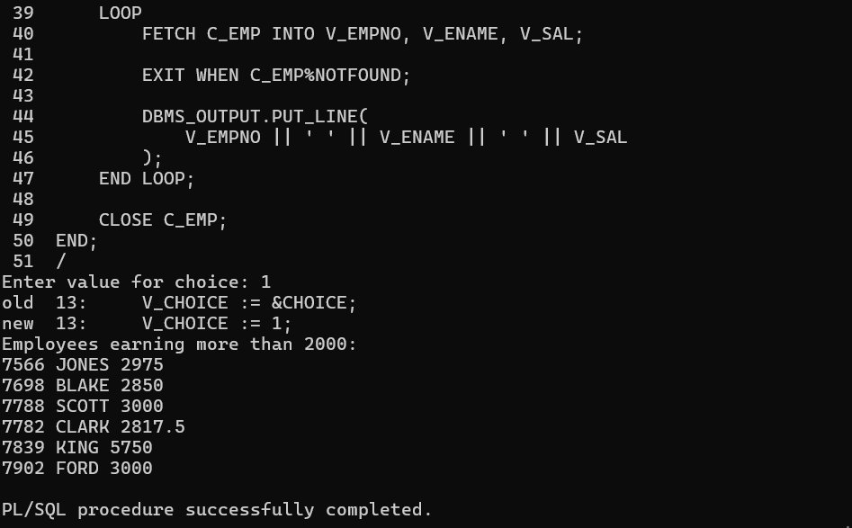

Hands-on Assignment(Handling Exceptions)
1. Create a table MESSAGES with a column RESULT of type VARCHAR2(1000).
Write a program that prompts for SAL and gets the corresponding ENAME from the EMP table. Do not use Explicit Cursors.
If the value entered returns one row, insert into MESSAGES as ENAME || '|' || SAL.
If the value returned is more than one row, insert into MESSAGES as 'More than one employee with a salary <>'.
If no value is returned, insert into MESSAGES as 'No Employee with that salary <>'.
Any other error insert 'Other Error'.
Use all NAMED EXCEPTION HANDLERS.
Program:
CREATE TABLE MESSAGES (RESULT VARCHAR2(1000));
SET SERVEROUTPUT ON;
DECLARE
V_SAL EMP.SAL%TYPE;
V_ENAME EMP.ENAME%TYPE;
BEGIN
V_SAL := &SAL;
SELECT ENAME INTO V_ENAME FROM EMP
WHERE SAL = V_SAL;
INSERT INTO MESSAGES
VALUES (V_ENAME || '|' || V_SAL);
DBMS_OUTPUT.PUT_LINE('Record inserted successfully.');
EXCEPTION
WHEN TOO_MANY_ROWS THEN
INSERT INTO MESSAGES
VALUES ('More than one employee with a salary ' || V_SAL);
DBMS_OUTPUT.PUT_LINE('More than one employee with a salary ' || V_SAL );
WHEN NO_DATA_FOUND THEN
INSERT INTO MESSAGES
VALUES ('No Employee with that salary ' || V_SAL);
DBMS_OUTPUT.PUT_LINE('No Employee with that salary ' || V_SAL);
WHEN OTHERS THEN
INSERT INTO MESSAGES
VALUES ('Other Error');
DBMS_OUTPUT.PUT_LINE('Other Error');
END;
/
Output:
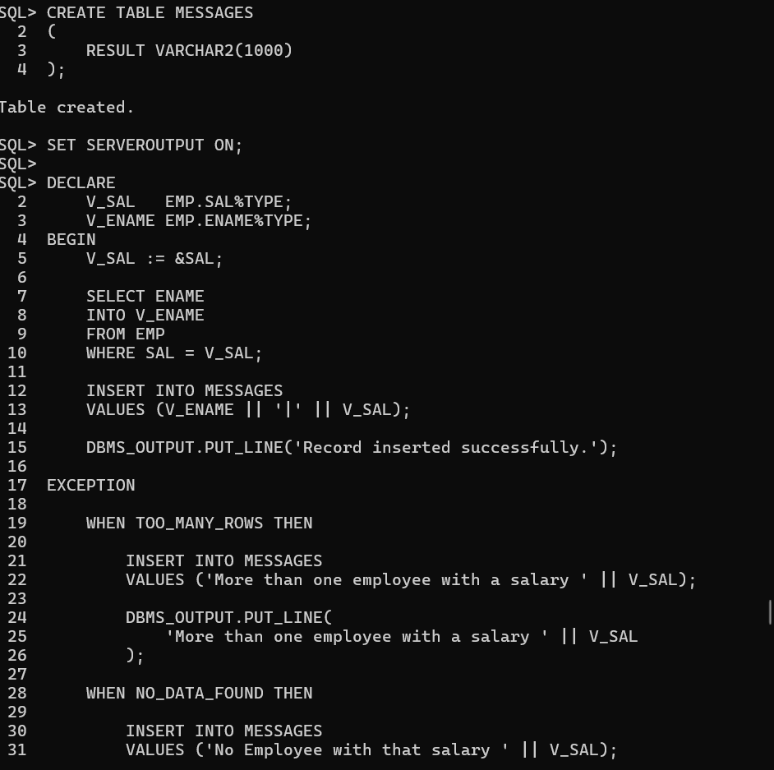
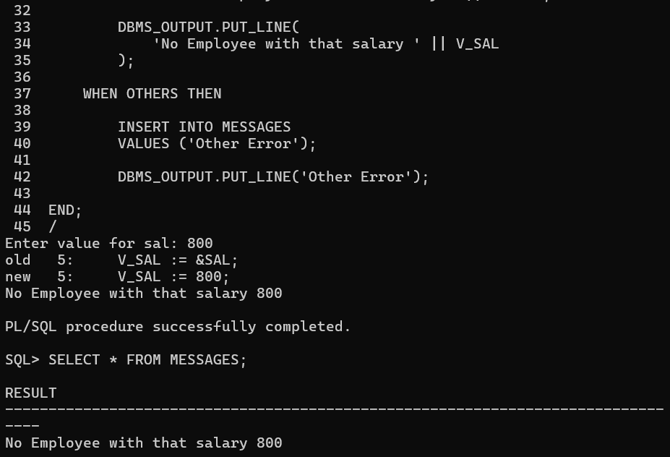

2. Write a program that will prompt for EMPNO, ENAME, SAL and insert them into the EMP table.
Use Unnamed system-defined exception handler.
Program:
SET SERVEROUTPUT ON;
DECLARE
V_EMPNO EMP.EMPNO%TYPE;
V_ENAME EMP.ENAME%TYPE;
V_SAL EMP.SAL%TYPE;
E_DUPLICATE EXCEPTION;
PRAGMA EXCEPTION_INIT(E_DUPLICATE, -1);
BEGIN
V_EMPNO := &EMPNO;
V_ENAME := '&ENAME';
V_SAL := &SAL;
INSERT INTO EMP(EMPNO, ENAME, SAL)
VALUES(V_EMPNO, V_ENAME, V_SAL);
COMMIT;
DBMS_OUTPUT.PUT_LINE('Employee inserted successfully.');
EXCEPTION
WHEN E_DUPLICATE THEN
DBMS_OUTPUT.PUT_LINE( 'Employee number already exists.');
WHEN OTHERS THEN
DBMS_OUTPUT.PUT_LINE('Other Error: ' || SQLERRM);
END;
/
Output:
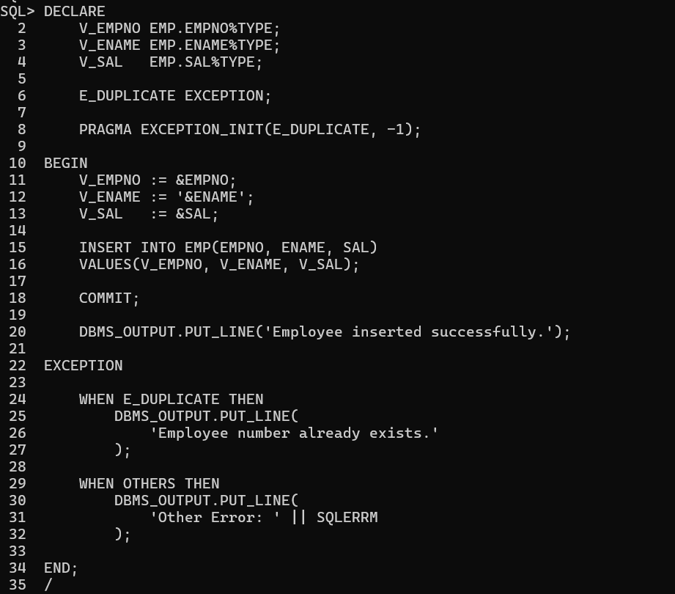

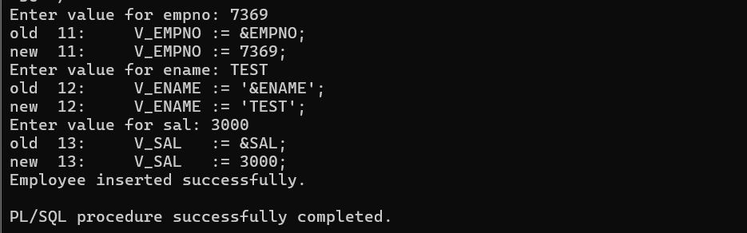

3.Write a program that will prompt for an EMPNO and delete the employee from the EMP table. Handle with User Defined Exceptions.
Program:
SET SERVEROUTPUT ON;
DECLARE
V_EMPNO EMP.EMPNO%TYPE;
E_EMP_NOT_FOUND EXCEPTION;
BEGIN
V_EMPNO := &EMPNO;
DELETE FROM EMP WHERE EMPNO = V_EMPNO;
IF SQL%ROWCOUNT = 0 THEN
RAISE E_EMP_NOT_FOUND;
END IF;
COMMIT;
DBMS_OUTPUT.PUT_LINE('Employee ' || V_EMPNO || ' deleted successfully.' );
EXCEPTION
WHEN E_EMP_NOT_FOUND THEN
DBMS_OUTPUT.PUT_LINE('Employee ' || V_EMPNO || ' not found.' );
WHEN OTHERS THEN
DBMS_OUTPUT.PUT_LINE('Other Error: ' || SQLERRM );
END;
/

Output:
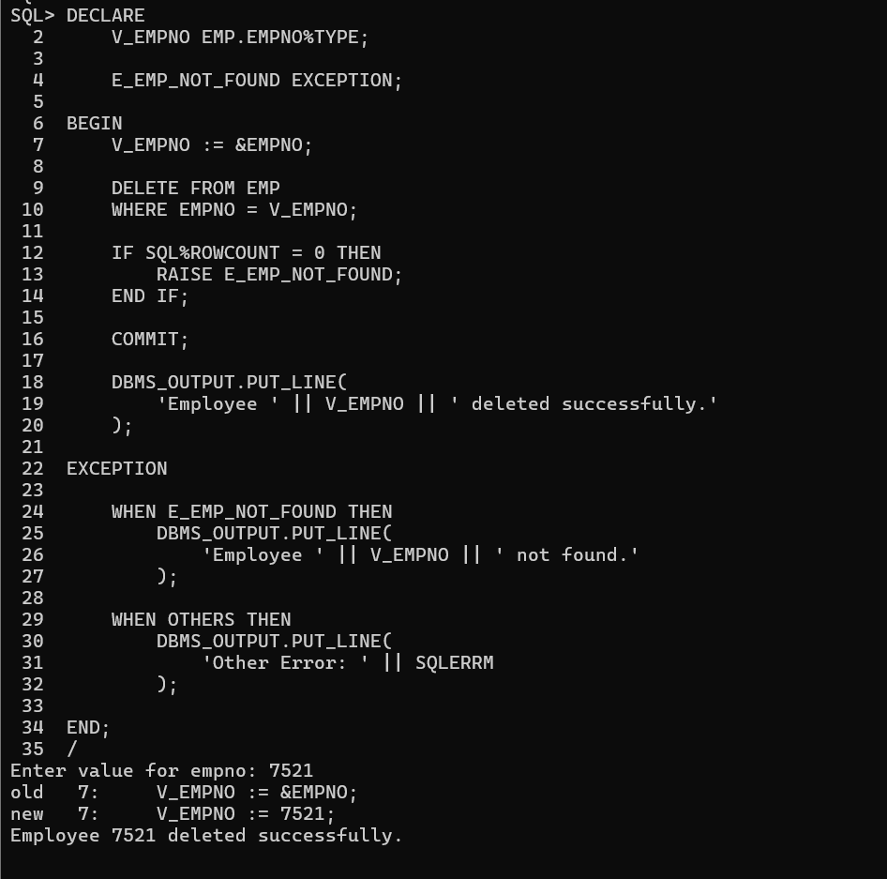

4. Create a stock table with columns PNO, PNAME, RATE AND TR_QTY.
Insert some records in this table.
Create a PL/SQL block that takes PNO, TR_TYPE and TR_QTY from the Stock Table.
If PNO is found and TR_TYPE is 'R' then update the TR_QTY with old TR_QTY plus new TR_QTY.
If PNO exists and TR_TYPE is 'I' then update the TR_QTY with old TR_QTY minus new TR_QTY.
Handle the user-defined exceptions using USER DEFINED EXCEPTION HANDLERS.
Query:
For Creating Table:
CREATE TABLE STOCK ( PNO NUMBER(4) PRIMARY KEY,
PNAME VARCHAR2(30),
RATE NUMBER(10,2),
TR_QTY NUMBER(10));
For Inserting values into the table:
INSERT INTO STOCK VALUES (101, 'PEN', 10, 100);
INSERT INTO STOCK VALUES (102, 'PENCIL', 5, 200);
INSERT INTO STOCK VALUES (103, 'BOOK', 50, 150);
INSERT INTO STOCK VALUES (104, 'BAG', 500, 50);
INSERT INTO STOCK VALUES (105, 'SCALE', 20, 100);
COMMIT;
Checking the table:
SELECT * FROM STOCK;
Program:
SET SERVEROUTPUT ON;
DECLARE
V_PNO STOCK.PNO%TYPE;
V_TR_TYPE CHAR(1);
V_TR_QTY STOCK.TR_QTY%TYPE;
V_OLD_QTY STOCK.TR_QTY%TYPE;
E_PNO_NOT_FOUND EXCEPTION;
E_INVALID_TYPE EXCEPTION;
E_INSUFFICIENT_QTY EXCEPTION;
BEGIN
V_PNO := &PNO;
V_TR_TYPE := UPPER('&TR_TYPE');
V_TR_QTY := &TR_QTY;
BEGIN
SELECT TR_QTY
INTO V_OLD_QTY
FROM STOCK
WHERE PNO = V_PNO;
EXCEPTION
WHEN NO_DATA_FOUND THEN
RAISE E_PNO_NOT_FOUND;
END;
IF V_TR_TYPE = 'R' THEN
UPDATE STOCK
SET TR_QTY = TR_QTY + V_TR_QTY
WHERE PNO = V_PNO;
DBMS_OUTPUT.PUT_LINE('Stock received. Quantity increased.' );
ELSIF V_TR_TYPE = 'I' THEN
IF V_TR_QTY > V_OLD_QTY THEN
RAISE E_INSUFFICIENT_QTY;
END IF;
UPDATE STOCK
SET TR_QTY = TR_QTY - V_TR_QTY
WHERE PNO = V_PNO;
DBMS_OUTPUT.PUT_LINE('Stock issued. Quantity decreased.’);
ELSE
RAISE E_INVALID_TYPE;
END IF;
COMMIT;
EXCEPTION
WHEN E_PNO_NOT_FOUND THEN
DBMS_OUTPUT.PUT_LINE('Product number does not exist.' );
WHEN E_INVALID_TYPE THEN
DBMS_OUTPUT.PUT_LINE('Invalid Transaction Type. Use R or I.’ );
WHEN E_INSUFFICIENT_QTY THEN
DBMS_OUTPUT.PUT_LINE('Insufficient Stock.' );
WHEN OTHERS THEN
DBMS_OUTPUT.PUT_LINE('Other Error: ' || SQLERRM);
END;
/
Output:
